EXP 8
Consider a Online Exam Registration Portal. Develop a JavaScript program that will validate the controls in the forms you have created for the application. State the assumptions you make (business logic you are taking into consideration). Note: Your application must access a database using Servlet/JSP.

AIM
To develop an Online Exam Registration Portal that validates user inputs using JavaScript on the client side and accesses a database using Servlet/JSP for storing and processing registration details.
ALGORITHM
- Start the application.
- Display the registration form to the user.
- Accept user inputs such as name, email, password, phone number, and exam details.
- Perform client-side validation using JavaScript:
  - Check for empty fields.
  - Validate email format.
  - Validate password strength.
  - Validate phone number length and format.
- If validation fails:
  - Display appropriate error messages.
  - Prevent form submission.
- If validation is successful:
  - Submit the form to the server (Servlet/JSP).
- On the server side:
  - Receive the form data.
  - Perform server-side validation.
  - Connect to the database.
- Store user details in the database.
- Generate confirmation message for successful registration.
- Stop the application.

STEPS
- Design the registration form with fields like name, email, password, phone number, exam selection, and date.
- Implement JavaScript validation for all form controls.
- Ensure proper error messages are displayed for invalid inputs.
- Configure Servlet/JSP to handle form submission.
- Establish database connectivity using JDBC.
- Create a database table for storing registration details.
- Insert validated data into the database.
- Retrieve and display confirmation details to the user.
- Handle duplicate registrations and invalid data cases.
- Test the application for different input scenarios.
ASSUMPTIONS (BUSINESS LOGIC)
- Each user must register with a unique email ID.
- Password must meet minimum security requirements (e.g., length, characters).
- Phone number must be exactly 10 digits.
- All fields are mandatory.
- A user can register for only one exam at a time.
- Exam date must be a valid future date.
- Database stores all user and exam details securely.
- Server-side validation is mandatory even after client-side validation.
- Duplicate registrations are not allowed.
- Proper error handling and user feedback are provided.
Code:
<!-- library.html -->

<!DOCTYPE html>
<html>
<head>
<title>Library Management System</title>

<style>

body{
font-family: Arial;
background-color: #f2f2f2;
}

.container{
width: 400px;
margin: auto;
background: white;
padding: 20px;
margin-top: 50px;
border-radius: 10px;
box-shadow: 0px 0px 10px gray;
}

h2{
text-align: center;
color: darkblue;
}

input{
width: 100%;
padding: 10px;
margin-top: 10px;
}

button{
width: 100%;
padding: 10px;
background-color: green;
color: white;
border: none;
margin-top: 15px;
cursor: pointer;
}

</style>

<script>

function validateForm(){

let student = document.getElementById("student").value.trim();
let book = document.getElementById("book").value.trim();
let email = document.getElementById("email").value.trim();
let mobile = document.getElementById("mobile").value.trim();
let days = document.getElementById("days").value.trim();

// Student Name Validation
let namePattern = /^[A-Za-z ]+$/;

if(student == "" || !namePattern.test(student)){
alert("Enter valid Student Name");
return false;
}

// Book Name Validation
if(book == ""){
alert("Book Name should not be empty");
return false;
}

// Email Validation
let emailPattern = /^[^ ]+@[^ ]+\.[a-z]{2,3}$/;

if(!email.match(emailPattern)){
alert("Enter valid Email ID");
return false;
}

// Mobile Validation
let mobilePattern = /^[0-9]{10}$/;

if(!mobile.match(mobilePattern)){
alert("Mobile Number must contain 10 digits");
return false;
}

// Days Validation
if(days <= 0 || days > 30){
alert("Borrow days should be between 1 and 30");
return false;
}

alert("Form Submitted Successfully");
return true;
}

</script>

</head>

<body>

<div class="container">

<h2>Library Management System</h2>

<form action="LibraryServlet" method="post"
onsubmit="return validateForm()">

Student Name:
<input type="text" id="student" name="student">

Book Name:
<input type="text" id="book" name="book">

Email:
<input type="text" id="email" name="email">

Mobile Number:
<input type="text" id="mobile" name="mobile">

Borrow Days:
<input type="number" id="days" name="days">

<button type="submit">Submit</button>

</form>

</div>

</body>
</html>
OUTPUT:
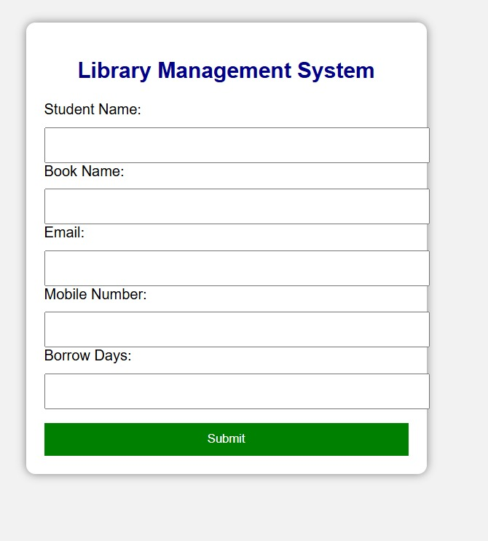

RESULT
The Online Exam Registration Portal successfully validates user inputs using JavaScript and stores the validated data in a database using Servlet/JSP, ensuring accurate and secure registration.

